**Portion Size Activity - KEY**

1. Which one of these items represent a serving size of a fruit?

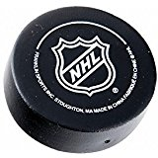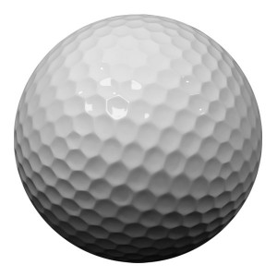Golf ball **Baseball** Hockey Puck

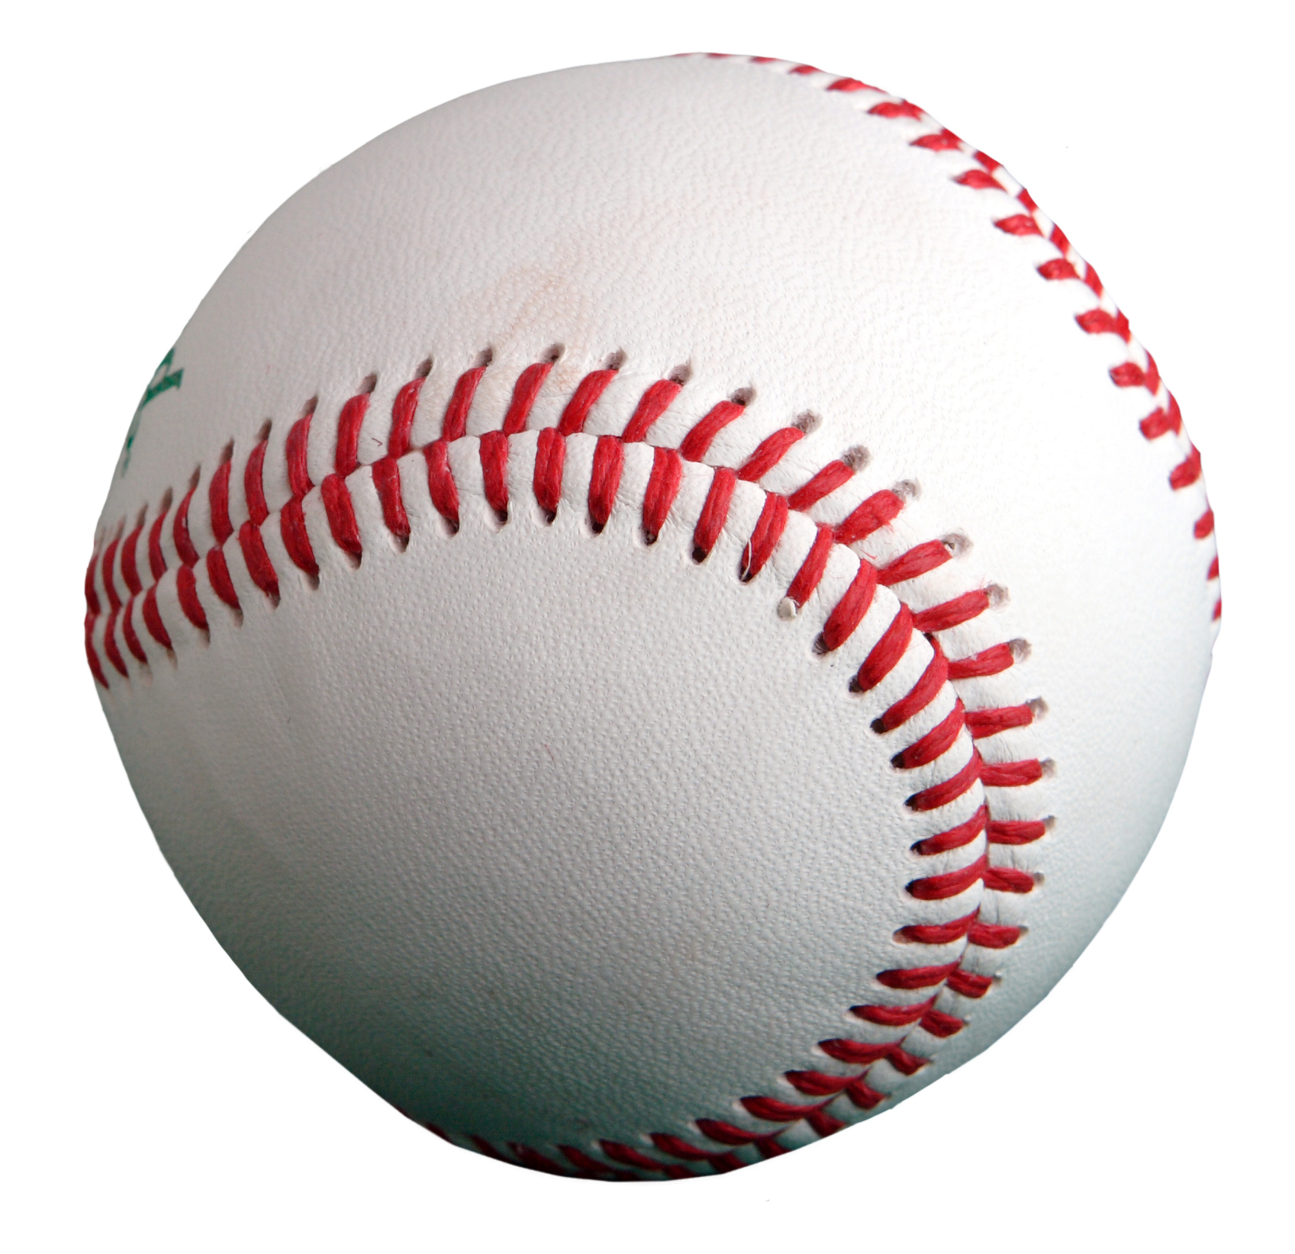

1. Which one of these items represent a serving size (3oz) of chicken?

**Deck of cards** Computer mouse Punching fists

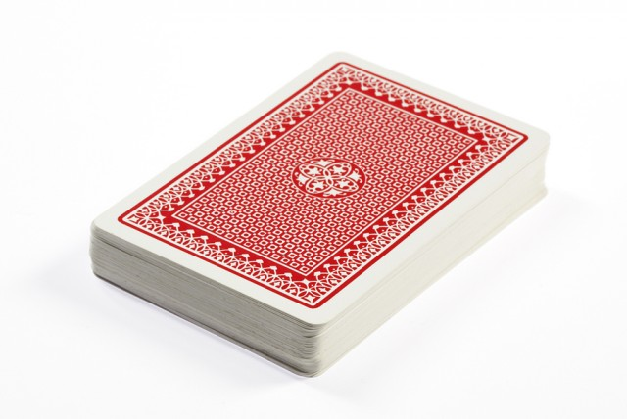

1. Which one of these items represent a serving size (1oz) of cheese?

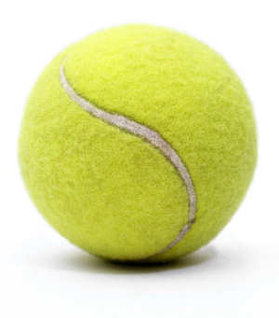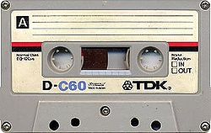Cassette tape **4 dice**  Tennis ball

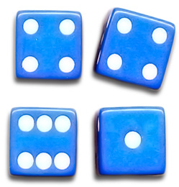

1. A potato is equivalent of the serving size of?

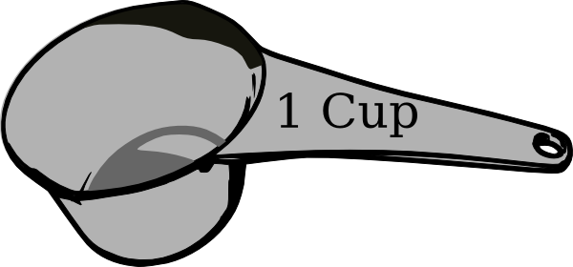**1 cup**  ½ cup 2 tablespoons

