 | Tip: | Picture:
Week 1: | The average holiday dinner is 3,000 calories. What are you going to do to ensure you are staying on track this holiday season?  Plan ahead and find some healthy holiday recipes.  Have you checked out the Healthy Recipes on the Healthy Steps Nutrition Website?  There are recipes such as healthy stuffing, mashed cauliflower and green bean casserole.  Download graphic:  http://growyournutritionbusiness.com/wp-content/uploads/2018/10/November-Nutrition-Tips.png | 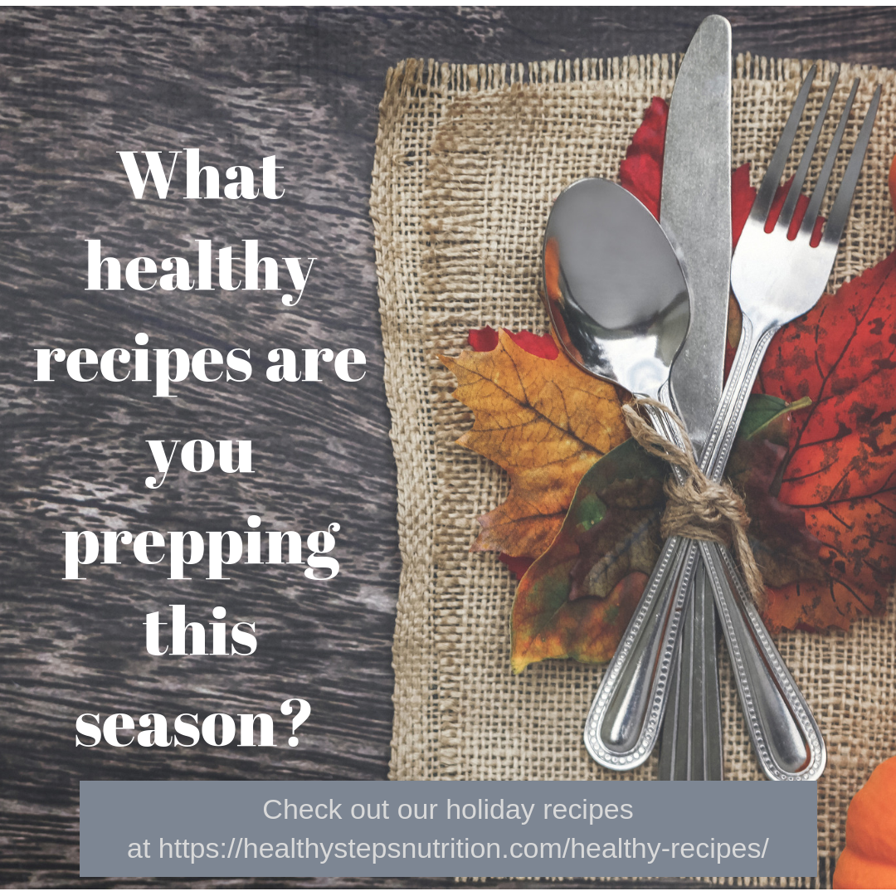
Week 2: | Don’t forget to stick to the basics and the PLATE METHOD this holiday season.  ½ non-starchy veggies • ¼ lean meat • ¼ starch  Download graphic:  http://growyournutritionbusiness.com/wp-content/uploads/2018/10/AdobeStock_177041056.jpeg | 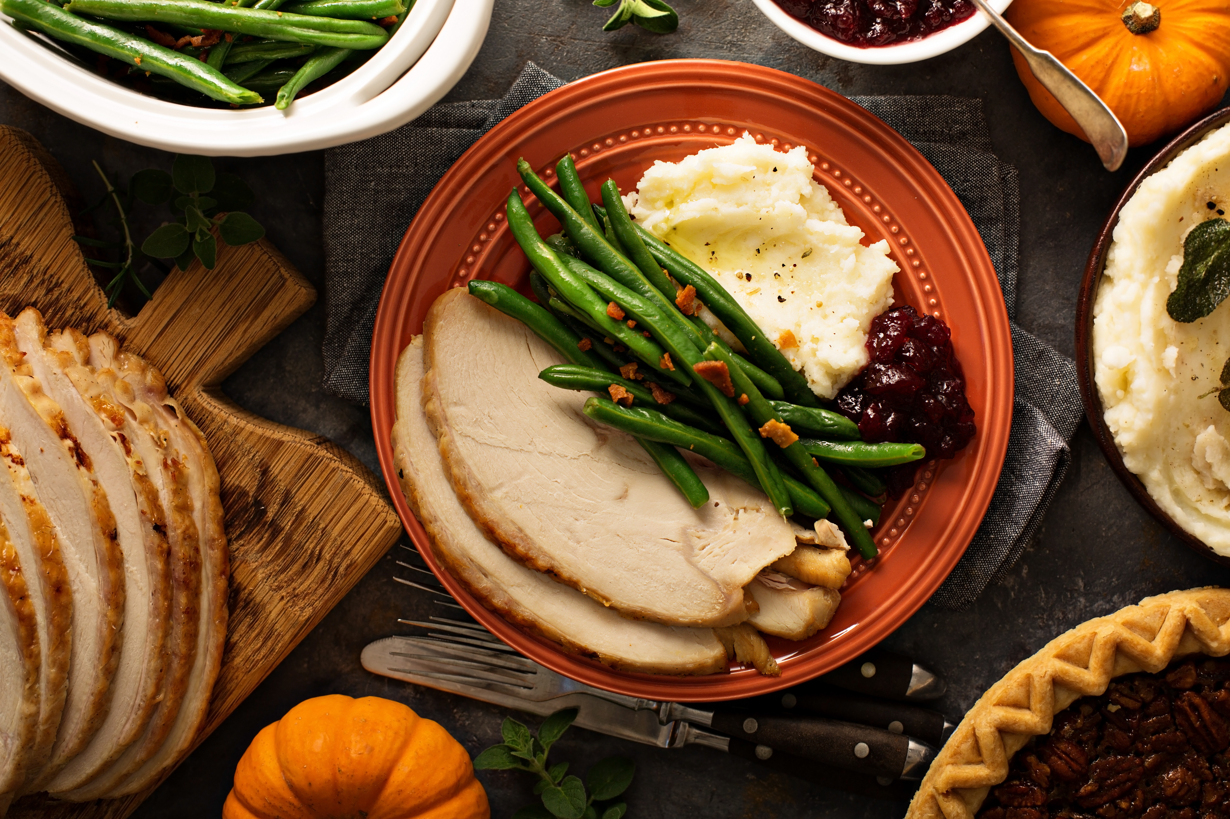
Week 3: | Looking for a way to put a healthy spin on your favorite recipes?  Try these healthy substitutions! By replacing some ingredients, you can cut the calories, fat, carbs and sugar drastically!  Download graphic:  http://growyournutritionbusiness.com/wp-content/uploads/2018/10/October-Nutrition-Hours.png | 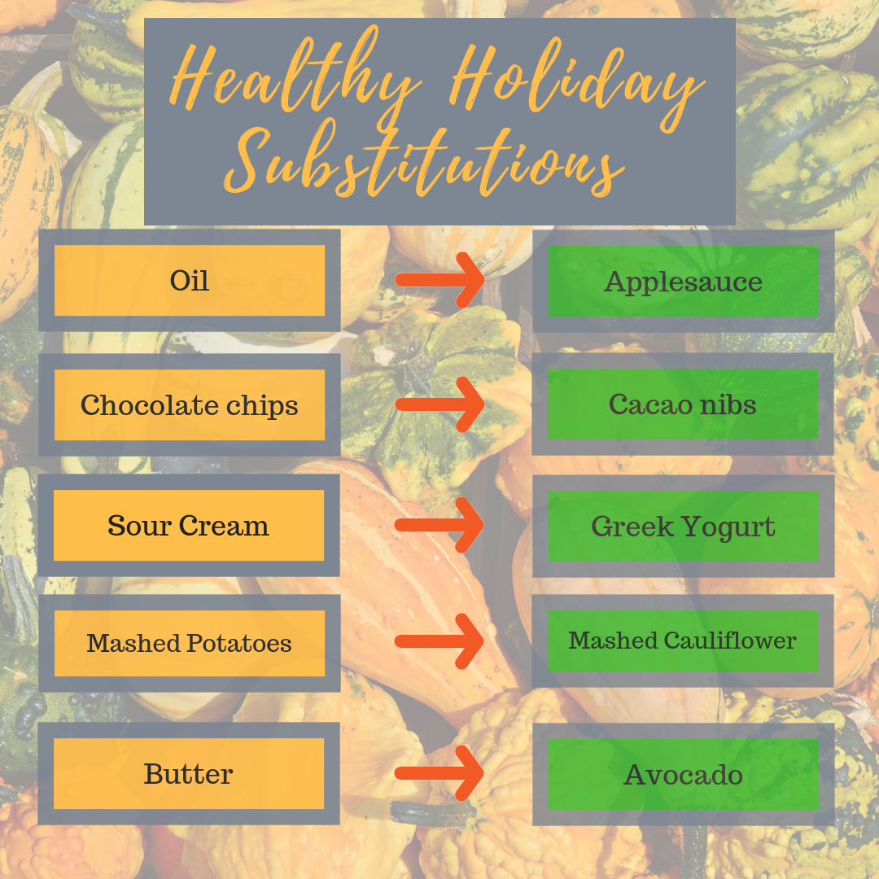
Week 4: | Do you have dinner parties to go to this holiday season?  Here are some tips to stay on track:  Offer to bring a healthy dish • Carry water with you at all times • Don’t stand next to the food table • Focus on spending quality time with family and friends instead of overindulging in treats and food • Get your sweat in • Load up on non-starchy veggies • Don’t skip meals or go to a party hungry (eat a balanced snack before) • Slow down- remember your brain is 15 minutes behind your belly • Eat your veggies first then protein and save the starch for the end • Lastly, set realistic goals and ENJOY this holiday season  Download graphic:  http://growyournutritionbusiness.com/wp-content/uploads/2018/10/AdobeStock_172657124.jpeg

